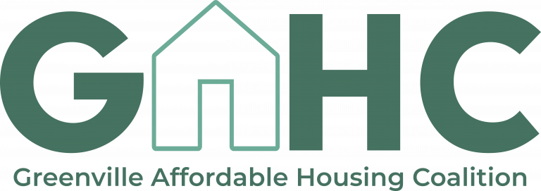
Greenville Affordable Housing Coalition Large Group Meeting
Wednesday, August 4th, 9:00-11:00 a.m.
Minutes

- Welcome
- Updates
  - County Council budget (John Castile, GCRA)
    - Council chose to allocate an additional $10 million for affordable housing over the next two years → plan going forward is for GCRA, GHF, and the County Administrator to develop a plan for how to use funding
    - Thank you to everyone who has worked to make this a priority at County Council, and congratulations!
  - American Rescue Plan (Lorain Crowl, UHC)
    - Through the Graham Foundation, Rethinking Homelessness (an organization with a vision for how to deploy ARP dollars) provided a six week intensive training program for ARP dollars
    - Greenville Cares (ARP partnership)
    - ARP Plan
      - ERAP round I and II (through Greenville County)
        - Used for rental/utilities assistance, case management, housing support services
      - Emergency Solutions Grant funding deployed for outreach/shelter services, homelessness prevention, rapid re-housing
      - Emergency Housing Vouchers (TGHA)
        - Targeted individuals in shelter, families in shelter, and special populations (domestic violence victims, veterans, youth)
        - 40 applications in, 20 approved and in progress
      - HOME program
        - Funds used for property acquisition, rent stabilization, development/rehab
  - Emergency Rental Assistance Program at Greenville County (Nicole Wood, Meredith Papapieris)
    - ERAP 1
      - Greenville County received $15 million for emergency rental assistance in January
      - Launched program in March in partnership with Neighborly software
      - Eligibility: at or below 80% AMI for Greenville County, reduction in income due to COVID, and risk for homelessness/housing instability
      - Covers rent (up to 3 months in the future), rental arrears (up to 12 months), and utilities arrears (electric, gas, and water)
      - Payments made directly to landlord/utility provider
      - Application is linked between tenants and landlords (both can apply and invite the other)
      - Current turnaround time is 5 days for a complete submission
      - Currently, $6.45 million dollars have been disbursed to 1413 tenants and 396 unique landlords
    - ERAP 2
      - Received an additional award in May for $12.5 million in additional emergency rental assistance funding
      - Currently partnering with local housing non-profits on a holistic emergency housing program focusing on homeless families and others with case management, outreach, deposits and rental assistance
        - Hoping to launch in August
        - Creating an outreach strategy in partnership with other housing non-profits
          - Goal is to get the word out and make sure that everyone has access (utilizing voices that are already present in the community)
          - Partners hiring an Outreach Coordinator
        - Provide trainings for how to go through the applications
        - Partnering with organizations that can provide an access point (Greenville County Schools, library system, YMCA)
      - If you would like to help (such as by distributing promotional material or serving as an access point), contact Nicole, Meredith, Tina, Lorain, or Heather Gatchell at GHA
  - News coverage:
    - Greenville Journal - Brick by brick: Greenville’s Affordable Houisng Coalition uses modern tools to meet a growing need (June 3)
    - Greenville News - What does it take to afford affordable housing in Greenville? You might be surprised (June 30)
    - Greenville News - The affordable housing planned in Greenville largely ignores those who need it most (June 30)
- Housing Production Report (Lisa Lanni)
  - Mapping and surveys are giving the group a good understanding of where we are now
    - Have been hitting above the 60% AMI mark well (about 1300 units), but need to focus on producing housing for 30-60%
      - How do we reach the lower AMI brackets?
    - Getting the word out to developers who aren’t familiar with Greenville’s affordable housing incentives/funding
    - Newest layer on GAHC map: TGHA housing vouchers
      - Map needs more submissions to survey to make it more comprehensive/accurate
- Housing Preservation Report (Brian Albers)
  - Single-family home preservation
    - Low-interest rehabilitation loan program
      - Helping people who live on fixed incomes age in place
      - Exploring programs that are especially for folks in the 80-120% AMI range
        - For people below 80%, we already have established programs in Greenville County
    - Also looking at property tax freezes or abatements
  - Multifamily preservation
    - Success story: Affordable Upstate and Greenville Housing Fund
      - Affordable Upstate went under contract to purchase Parkins Ridge Townhomes in March 2020, then partnered with GHF to help make it more financially feasible
      - Affordable Upstate helped repair the exteriors of the properties to make it more livable and visually appealing (new siding, dumpster enclosure, mailbox station, lighting, entrance, signage, front doors, parking lot)
    - Naturally occurring affordable housing (NOAH)
      - Preventing units from being lost to the market due to increased turnover
- Housing Tools Report (Inez Morris, Jerry Blassingame)
  - Foreclosure Prevention Fund
    - Arose from discussions about expanding the Homestead exemption
    - Possibility of being able to help those who are going into foreclosure
    - Legacy resident programs
      - How do we identify who is a legacy resident? How does the legacy designation pass from the original resident to the rest of the family?
  - IDA programs and down payment assistance
    - IDA programs are a long-term solution to building wealth and financial literacy
      - Has been very successful in small-scale, in-house organizations (such as at Soteria), but the larger Greenville County IDA program’s federal funding ran out and the program faded away
    - Continuing to work with United Way and CommunityWorks
    - How could we get large employers (hospital systems, etc) to commit dollars toward down payment assistance or IDA programs?
- Policy Prioritization Survey Results
  - Top three: housing stabilization (local rent subsidy), affordable housing incentives in the City, and housing preservation (low interest loan/grant program, tax abatements)
  - Using an aggregate scoring system, the eight policies in order of priority is:
    - Affordable housing incentives from the city
    - Housing preservation (low interest loan/grant program, tax abatements)
    - Housing stabilization (local rent subsidy)
    - Greenville County matching LIHTC dollars
    - Expanded Homestead exemption/foreclosure prevention fund
    - Increased resources for affordable homeownership
    - Landlord registry
    - Bailey Bill authorization (affordable housing component authorized)
  - This aggregate data will go back to the steering committee and inform decision-making, and it can also inform the plan for the $10 million from the County
- Adjourn

