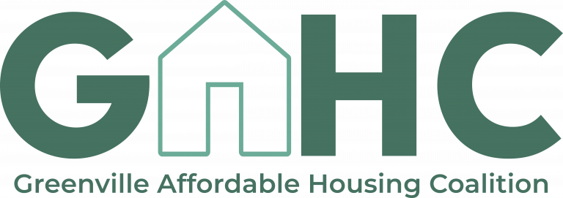
Quarterly Large Group Meeting
5.5.2021 9:00am

Revisit February meeting
- Collective impact presentation and discussion: how can we ensure that our collective impact approach doesn’t lose momentum or fizzle out?
  - Share accomplishments
  - Meet purposefully
  - Have accountability (dashboard, map system)
  - Encourage and coordinate natural break-off groups

Reports from Working Group Co-chairs
- Housing Production Group (Taylor Davis and Lisa Lanni)
  - 2 meetings since February
  - Primary task has been trying to quantify production in Greenville County in foreseeable future
  - Seems to be the case that current production levels will allow the group to meet their goal of producing 1000 units per year
    - Majority of this production is rental for 60-80% AMI
      - However, production for homeownership and for rental for 30-60% AMI is pretty low
    - Affordable housing for seniors (55+) is a large percentage of recent production
      - Need to deliver more to families
    - 1-2 bedroom units are key (since biggest population growth projected in Greenville County is under 35 and over 55, and market isn’t providing for that)
  - Next steps:
    - Should we seek out a rental subsidy to bring people from 30% AMI to 50/60% AMI, or try to finance 30% units?
      - How do we operate more affordable units in production?
      - How do we bring in new investment to reach our goals?
      - How do we support organizations dedicated to homelessness and mental health services?
        - Veteran housing
        - Permanent supportive housing
        - Partner with Department of Mental Health - limited funding
      - Making homeownership affordable right now is fairly implausible
      - Look into rental subsidy/rent control housing stabilization policies and look at examples of other municipalities that do it well
      - Integrated supportive housing model
    - Larger group: complete current production survey for your organization (if applicable)
    - Prioritization of policies
- Housing Preservation Group (Chris Manley and Brian Albers)
  - Since February, group has been trying to get a baseline of how many units are we preserving right now and what obstacles organizations face
    - Have learned that we might need to up our preservation goals
    - Barriers:
      - Inflexible funding
      - High cost of construction
      - Not a lot of organizations trying to preserve multi-family homes (most preservation is single family)
        - Difficulty finding multi-family housing that is priced appropriately
    - Interest in creating landlord registries (to create incentivization programs)
  - Sub-group meeting about housing trust fund dollars
    - Barriers to emergency and owner-occupied repairs
      - Limit to supportive housing projects
      - Lack of uniform inspections
      - Contractors unable to wait long lengths of time for payment
    - Investing in improving infrastructure in lower income neighborhoods
  - Next steps:
    - Continue housing trust fund conversations
    - Larger group: complete current preservation survey for your organization (if applicable)
    - Prioritization of policies
- Housing Tools Group (Inez Morris and Jerry Blassingame)
  - Meeting in conjunction with REEM Commission about identifying barriers and accelerators to Black homeownership
    - Barriers: education, high enough income levels, lower appraisals, higher interest rates, losing our talent pool to Charlotte/Atlanta (prohibits economic mobility), damaged credit (often not the person’s fault → parents might’ve used their social security info, for example)
    - Accelerators: financial education, down payment assistance, freezing property taxes (especially for legacy residents), IDA programs (and other similar programs)
  - Have been identifying assets/existing programs in our community that work
  - Citizen coalition arm
    - Want citizen action at council meetings, etc
      - Will allow coalition to respond quicker
    - Helps to bring people with lived experiences into the coalition
    - Want to break down barriers so that anyone can participate
    - Will include advocacy trainings (by partners, etc) so people feel comfortable standing up in front of council
    - Will require a blend of strategies to engage different groups (social media for younger people vs mail to older people, figuring out how to help people be able to attend meetings, etc)
  - Next steps:
    - Identifying homeowners and landlord/tenant partnerships
    - Prioritization of policy
  - “Everyone has an affordable housing story, even if they don’t realize it”
    - placing parents into affordable senior housing
    - finding affordable housing when just out of college

Advocacy report
- Completed efforts:
  - TGHA: ability to issue bonds within the unincorporated parts of Greenville County (drafted a letter, signed by members of coalition and approved by County Board on April 28th)
  - Senate Bill 436 (CDC/CDFI Act): contact House Representative, should go on House floor May 6
  - Closing loophole on state LIHTC to prevent market from being only open to big players (should be signed by governor at the end of this month)
    - afterward, should see a new property tax incentive for nonprofits
  - Governor American Rescue Plan: opening up funds for SC to be able to access them for mortgage and rental assistance, governor signed it a few weeks ago
  - HOME Funding: reach out to congressional representatives (up to $1.9 trillion)
- Still to come:
  - Tree ordinance within the city
  - Housing trust fund and SCACED
  - Evictions (Furman data) → what can we do locally?
  - ARP housing dollars → need to coordinate what we’re doing to address housing insecurity as a result of COVID

Other Updates
- Equitable development incubator: how to we increase and sustain our commitment to racial equity (will help to support and build up capacity for minority contractors and untapped talent)
  - partnering with Melanie Brown and Restoration 52, LLC
- Presentation of dashboard and map
  - Dashboard: overview page, progress page
    - To get data and track progress, we’ll send out a survey twice yearly
    - Dashboard should be live online in a few weeks
  - Map: shows what’s available as affordable housing and displays that spatially so that we can determine prime locations for affordable housing units (prevent concentrated poverty, etc)
    - Shows publicly reported projects, plus ideal development areas from Strategic Plans
    - Also shows affordable housing sites that could be/have been lost to the market

