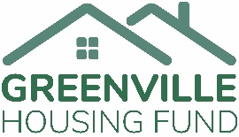
Greenville Housing Fund is devastated by the police violence and racism that is plaguing our country. It is the continuation of a long history of targeting and killing people of color. In light of the recent taking of black lives — the murders of George Floyd, Breonna Taylor, Tony McDade, and Ahmaud Arbery– as well as the growing disparities in Greenville, our Board of Directors and staff reiterate our commitment to affordable housing. We believe that housing justice is racial justice. Every day we aim to make Greenville a more equitable place to live. We push ourselves to find new ways to enable inclusive and thriving neighborhoods in Greenville.
We encourage you to stand with all communities suffering from racist violence and acts of hate. Some of you have lived with the reality of these injustices and are already deeply involved in social justice advocacy. Others may have a new awareness of the systemic dehumanization of people of color and may be wondering how you can help.
We encourage you to educate yourself and others, give to organizations working for racial justice, listen to and lift up black voices, and do not be silent. This is not a one-time call to action. We ask you to continually be an advocate. Take care of yourself, your family, and your community. Love your neighbor, and be compassionate. Commit to justice, not just in the wake of these tragedies, but over the long term, and join us in our mission to make Greenville a more equitable place for all.

